Mohamed Khalid Ahmed – M00872862
CST2550 - Library
21/01/2024

Project Description
A small library needs a system to track the details of their available books and members. They provided you with the data source CSV file. The file contains details of all books that are available for members to borrow and return within three days. It is made available to you for implementation and testing, but the system should allow any file to be used.
All books have an id, name, author, type, and page count. The program will only be used by the librarian at the library (not by customers/members) and will not take payment details. The system should include the following functionality:
- Add a member – the librarian should be able to create a new member and display the new member’s details directly following the creation of the member.
- Issue a book to a member – the librarian should be able to issue a book to an individual member with a valid due date from the date of issue (3 days).
- Return a book – the librarian should be able to return a book from an individual member.
- Display all books borrowed by any individual member – the librarian should be able to display all books borrowed by an individual member.
- Calculate a fine for any individual member for overdue book(s) – upon the return of a book, if the book’s due date has expired, a fine should be calculated based on a rate of £1 per day overdue.

Planning
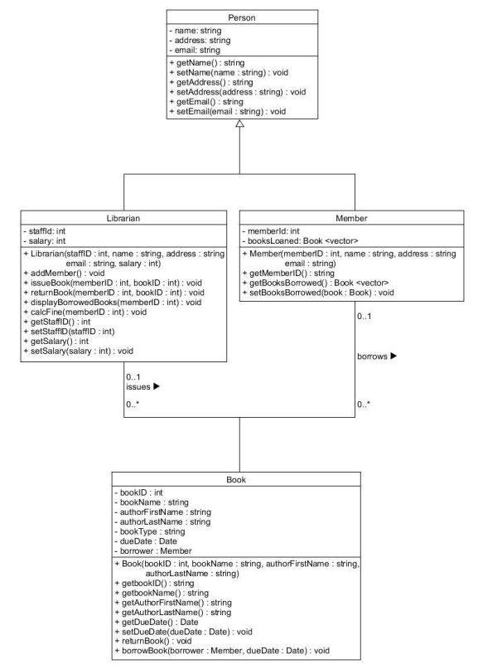
The first step to my planning was organizing each function to its desired classes using the UML diagram provided as reference.

I first created empty functions for each of the classes: Person, Librarian, Member, Book, before adding the logic to them. I started with the easiest ones first and slowly made my way to the harder functions. Its better to start with the easier functions because I never know how much time I could waste working on one hard function, so I left the harder ones last.
Most my time went into researching how to use unfamiliar libraries like fstream. Some examples of the easy ones are: addMember() and most of the get functions.
The hardest function for me which I scrapped because it mostly gave errors before committing was the calcFine() function. This was the hardest for me because I didn’t know how to properly use the time library to calculate the time that has passed for fines. The only successful thing I did with the time is calculate 3 days ahead for borrowing books using current time.
One thing I could have done better is to spend even more time researching and testing some concepts that I’m not familiar with yet.
Another thing I could have done better is first making the header files instead of working on everything in one file and then separating them. I thought it would be easier to work on one file so I don’t have to keep clicking and opening the other header files but I have learned that it’s better to separate them first since it keeps everything organized and not hard to deal with.

Version control
I used GitHub for version control for the program because of its feature to commit and push new updates. This means I can easily go back to an older version if anything goes wrong / don’t like the new version and need to recode it. Another reason its useful is because if I wanted to access that repo from another device I can very easily, and if my device breaks without backing up my files then I would know that its saved on GitHub servers so my work won’t be gone.

